**Defuse the Bomb – Ratio and Proportion**

The Mathematician, a notorious terrorist has planted a bomb. You must defuse that bomb using the mathematical clues he’s left.

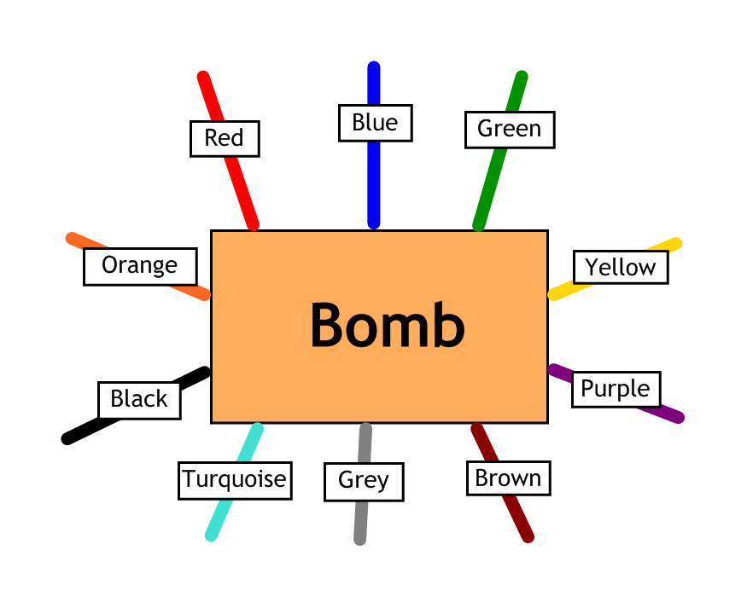

Answer the questions, then cut the coloured wires in the order that the answers appear, using the table below:

|  |  |  |  |  |  |  |  |  |  |
| --- | --- | --- | --- | --- | --- | --- | --- | --- | --- |
| Red | Blue | Green | Yellow | Purple | Brown | Grey | Turquoise | Black | Orange |
| 48 | 210 | 12 | 28 | 245 | 49 | 84 | 45 | 225 | 96 |

Here are the clues that show which order to cut the wires:

|  |  |
| --- | --- |
| 1 | Three pens cost £1.05. How much would seven pens cost in pence? |
| 2 | The ratio of girls to boys in a class is 3:2. If there are 18 girls, how may boys are there? |
| 3 | Alice and Brian share 63 sweets in the ratio 5:4. How many sweets does Brian get? |
| 4 | The ratio of Michael and Neil’s ages is 7:6. If Neil is really 42 years old, how old is Michael? |
| 5 | Benny, Jenny and Lenny win some £750 in a competition. The prize is shared in the ratio 2:3:5. How much did Jenny win? |
| 6 | Twelve books cost £51.60. How many books would I get for £193.50? |
| 7 | The ratio of boys to girls in a club is 4:3. If there are 48 boys, how many members of the club are there? |
| 8 | The ratio of the angles of a triangle is 3:8:4. What is the size of the largest angle? |